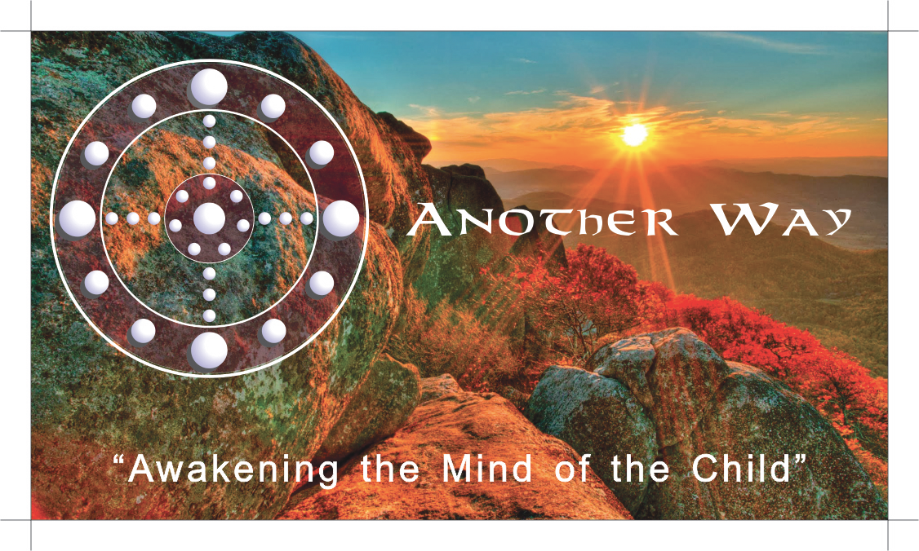

Another Way in the Wild
Enrollment Contract

Another Way School (AWS) is a non-profit 501 C (3) school meeting the needs of children ages 6-12 with classes for teens and adults in all of the Nature-based programs listed in this document. Private and semi-private lessons are available for young children 3 up to 6 years of age.
An experiential, Montessori-based educational center, Another Way is a place where children & adults can comprehend, copy, cooperate and collaborate with Nature in ways that foster the highest good of all Life and the natural joy that results when love is the guiding principle and extends to all living things.
The Lab School program for children 3-6 takes place on the school grounds with special arrangements if transition lessons at the resort are indicated. This contract represents a commitment between Another Way and the Parent/Guardian. Another Way outlines school policies and procedures on the website. By signing this contract, the Parent/Guardian agrees to abide by those policies and procedures.

Student: ________________________

Preferred Name: _________________________

Date of Birth: ____/____/______ Age: __________ Gender: Male Female

Parent/Guardian 1: _________________________________

Address: _____________

Phone: Email: _____________

Parent/Guardian 2: _________________________________

Address: _____________

Phone: Email: _______________________________________________

Listing of programs with tuitions, fees and the agreement for the 2018-19 school year:
- Another Way Program:

Another Way School is a multigenerational educational center developed to reconnect children and adults through direct experiences in Nature and with large animals to the fact that all life is an interconnected, all-inclusive whole. Though in the 21st Century, we seem to have largely forgotten that the gifts of civilization; the arts, music, the sciences, mathematics, and technology have all been and still are inspired by Nature.
The educational process at Another Way helps children and adults develop a profound respect for themselves, others, and the environment while developing critical thinking, problem-solving and domain & creativity relevant skills that can be applied to any area of interest.
The purpose is to foster the highest good of all life and the natural joy that results when love is the guiding principle.

Please check the program(s) in which you wish to enroll your child or yourself filling out all attached paperwork including the scheduling calendar and submit with payment.

Programs may take place from Monday through Thursday from 9am–3pm and 3-6pm
Private or group lessons may be scheduled on Friday morning
T.G.I. Friday group lesson is in the afternoon for skiing
Sunday has a Fun Day Sunday group ski lesson in the morning only

_____________Lab School: $900.00 * Nonrefundable Deposit: $600.00

The Lab School offers an adapted Outdoor Education & Norwegian Friluftsliv with Academic Enrichment. All activities take place on campus or in surrounding areas. Private and semi-private lessons are available for this age group, in particular, the 3-5 year-olds.

Students work from "the big picture" toward an increasing level of detail. Skills and concepts are reintroduced to them at increasing levels of complexity and abstraction over time. Along with the Montessori approach, we use compatible curriculum and programmatic elements of additional approaches and materials from the non-Montessori educational community that have been carefully researched to provide opportunities for enrichment the basic curriculum. Another Way provides individualized pacing and adaptation of the classroom programs to meet any style of learning. We teach based on the guiding principle of respect and appreciation of all life. We believe that learning is, and should be, joyful and activity based. Maximum number of children in this program: 12

4 Half-day Morning Sessions: 8:45 - 11:45 am
4 Half-day Afternoon Sessions: 12:45 - 3:45 pm
______________Norwegian Friluftsliv (Free-Air-Life) Program: $400 mo. 2xswk, 4 hours
We believe in the importance of providing experiences that connect the child to the joy and wonder of Nature. In the 21st Century, we seem to have largely forgotten that the gifts of civilization; the arts, music, the sciences, mathematics, and technology have all been, and, still are inspired by Nature.
Friluftsliv is a way of life. Another Way allows children to experience Friluftsliv through its various Nature programs. Through these experiences, children come to respect and appreciate Nature; awakening the mind to the beauty and infinite possibilities within themselves. The outcome: a child who is kind, confident, curious, aware, and, able to make healthy, life-affirming decisions.
Maximum number in class: 10 * Days for Groups: Tues and Thursday * Times: 9 am – 1:30 pm Special arrangements can be made for afternoon sessions locally * spring through summer we will have longer hours available for hikes
Additional fees may apply: Snowshoe, & field trips
____________Child-Centered Skiing Program: $800 per mo. 1xwk, 3 hours

Another Way offers a unique learning experience through Child-Centered Skiing, a developmental ski instructional program created by Diane Bode, Executive Director & Founder of Another Way. Diane’s developmental model for children’s ski instruction is used in ski resorts throughout the United States and the world.

In the Another Way Ski School, children learn high-level skiing skills on the school's practice slope and then experience transition lessons at local ski areas. We use a direct parallel approach based on the model presented in Child-Centered Skiing that includes ski conditioning and pre-ski development. Parents are responsible for purchasing a Season Pass for their child.

* Maximum number in class: 10 * Days to select a group lesson are: Monday through Friday
* Time: 8:30 – 12:00 * Private or Semi-Private Lessons may be scheduled Friday mornings
T.G.I. Friday group lesson may be scheduled in the afternoon as well for the Sunday Fun Day group lesson

Additional fees required in the ski program:
Ski equipment deposit: $500
Equipment lease: $150
Biomechanical assessment: $250
Orthotics if needed: $150

_____________Mindful Horsemanship Program (spring though Fall): $500.00 mo. 2xwk 2.5 hr.
The Another Way equestrian program develops communication skills, self-confidence, self-esteem, balance, coordination, motor planning, empathy, responsibility, and requires consistency in the student’s actions.
Students learn about equestrian tack, grooming, saddling, bridling, leading, mounting, dismounting, care & maintenance (including feeding, watering, hoof care) natural horsemanship groundwork, basic to advance level riding, (equestrian, English, and Western) pleasure and trail riding. Horse interactions are fun, kinesthetic, and tactile experiences that complement the student’s study of Natural and Human history through the Montessori Time Lines.
* Maximum number in class: 10 minimum 6 * Days to select a group lesson are: Monday, Tuesday, Wednesday or Thursday
* Lesson Times: (a) 9am to 11:30 am * (b) 1:00 to 3:30 * (c) 4pm to 6:30pm

_____________Way of the Wild Living History Program: $300 per month 1xwk 3 hours
An old American Indian proverb holds that “A people without knowledge of their history are like buffalo grass blowing in the wind.” Knowing history is important to knowing who you are and where you are going. Consciously aware, the present moment is the point of power. Cross-disciplinary life skills are learned as the children step into Living History. Respect, appreciation and problem-solving skills are developed as the children walk in the footsteps of the Native Peoples, the Colonials, the Mountain Men and the Pioneers who shaped our country.
The Living History and Frontier Skills program is offered to children ages 6 and above who have sufficient focus and skills to participate. Participation will be determined on a case-by-case basis.
The following are examples of specialty skills presented during the weekly classroom presentations given by teachers who are members of the American Mountain Man Association. Maximum number in class: 10
- Creating a shelter: Setting up a Tipi, Marquis Tent, constructing a Hogan, stacking-chinking logs to create a shelter
- Making clothing: Making moccasins, sewing frontier shirts, Possibles’ Bags, creating fibers, carding wool, spinning, dying and understanding how to weave cloth using ancient looms
- Transporting goods: Making a sled, making and using a travois, appreciating and learning how the partnership between the horse and human beings helped build civilization
- Tracking skill development: Recognizing animal tracks, understanding animal behaviors, appreciating ecological niches, making snares to secure food and the means to make clothing, making an Atlatl and using it in ancient games to develop skill and agility …
* Maximum number in class: 10 minimum 6 * Days to select a group lesson are: Monday, Tuesday, Wednesday or Thursday
* Group Lesson Times: (a) 9am to 12:00 * (b)1 pm to 4 pm * (c) 4:30pm to 7:30 pm (Teen and Adults only)

_____________Teen and Adult Program:
Another Way offers Teens and Adults the opportunity to develop and refine skills in Mindful Horsemanship, Child-Centered Skiing, Way of the Wild and the application of Montessori principles at home or in classrooms. Please check the program(s) in which you wish to enroll. Maximum number in class: 10
______Way of the Wild Living History Program: $300 per month 1x weekly 3 hours
______Child-Centered Skiing: $800 per month 1xweekly 3 hours
Additional fees apply (Please refer to this program as listed above)
______Mindful Horsemanship Program: $300 per month 1x weekly 3 hours
_____Montessori Method at home or in the classroom: $300 per month 1x weekly 3 hours
* Maximum number in class: 10 minimum 6 * Days to select a group lesson are: Monday, Tuesday, Wednesday or Thursday
* Group Lesson Times: (a)9am to 12:00 * (b)1pm to 4 pm * (c)4:30pm to 7:30pm (Teen and Adults only)

II. School Schedule: Another Way offers year-round programs for young children, teens, and adults. www.anotherwayschool.org.

III. Required Forms: The following forms become a permanent part of your child’s records and must be submitted along with this contract:
    - Health Records
    - Emergency Release Form
    - Transportation Agreement
    - Photo/Video Release
    - Tuition Agreement

IV. Uniform: Lab School students are required to wear the school uniform. (Please refer to information on the website and in Parent Policies.)

VI. Ski and Horse Program Adjustments: Another Way will, at its discretion, adjust the timing and content of the skiing and riding programs according to weather and other conditions affecting the safety and effectiveness of these programs.

VII. Classroom Observations: Another Way welcomes observational visits by Parents/ Guardians in the Lab School and other programs when they are scheduled in advance. The Parent/Guardian may email any questions or concerns to info@anotherwayschool.org.

VIII. Volunteer Participation: For parents with children in the Lab School, we are asking that parents put in 12 hours of volunteer time per year. Volunteering to work directly with children and staff will give you a greater understanding of the unique experiences we are providing and what it takes to offer our value-added services.

You may choose to volunteer helping with future fundraisers, soliciting donations, marketing, supervising during lunch hour, reading to children during the afternoon quiet time, assisting on Field Trips or helping with maintenance projects on the grounds.

IX. Field trips and additional fees: Field trips may require additional fees. All activities and events require Parent/Guardian’s signature on the form included in the Release Package. In advance of a field trip, Another Way will provide information concerning the activity.

X. Tuition Agreement: Tuition is due according to the following schedule:

Enrollment Deposit: Payment of $600.00 is attached to this contract to reserve your child's space. This is a non-refundable deposit.

Outdoor Program fees are prepaid. No processing fees are charged.

Lab School Tuition: Tuition can be prepaid. If tuition is paid monthly, an arrangement must be made for a direct deposit into our Living Matrix Education, Inc. dba Another Way Chase account.
Materials and program Fees: There may be additional materials fees for the Friluftsliv and Way of the Wild Program depending on the activity.

Refunds: No tuition or fees will be refunded upon early withdrawal or disciplinary expelling of a student. If tuition fees are still owed at this time, this remainder is expected from the Parent/Guardian. Students who withdraw at any time during a scheduled session are still responsible for tuition due on this contract unless previously arranged with Administration.

Non-Sufficient Funds: A $50.00 fee will be charged for payments returned due to insufficient funds.

XI. Disciplinary Expulsion Policy: Removal of a child from AWS for unresolvable behavior issues. Behavior that will lead to a child’s dismissal from school is aggressive-abusive behavior toward other children that could lead to physical injury and emotional stress.
If there is a behavior issue that fits this category, the parents will be notified immediately. A means for changing the child’s behavior will be addressed. This may include a recommendation that the children receive professional counseling. There may also be the necessity of hiring a shadow teacher at the parents’ expense.
If the child’s behavior is found to be unchanged when all reasonable means have been taken, the child’s parents will be asked to find another school for their child.
Incident Reports: An incident report must be written immediately and parents informed about the behavior. A behavioral plan needs to be put in place to help the child if there is a second occurrence. Parents must come and take the child home with a second occurrence.
If a child is in counseling, the therapist must be given the incident report the day of the incident. Parents are responsible for arranging for the therapist to work directly with staff to help the child.
Hiring a shadow teacher, at the parents’ expense may be required for the child to continue at AWS.
XII. Breach of Contract: Failure to abide by the terms of this contract or policies and procedures in the (website) will be considered a Breach of Contract and may result in the dismissal of the Student from Another Way. If this occurs, no refunds will be given and the Parent/Guardian will be responsible for any and all legal fees incurred during the process.

I acknowledge that I have had the opportunity to address any questions or concerns before signing this contract. I understand that my child’s educational experience is largely dependent on this mutual agreement with Another Way. By signing this contract, I agree to all the terms stated above.

Student Name:

Signed: Date:

Parent/Guardian Printed name:

Signed: Date:

Parent/Guardian Printed name:

Accepted: Another Way School

Signed: Date:

6587 Mountain View Drive * Park City, Utah 84098 * 435.615.1429
info@anotherwayschool.org * www.anotherwayschool.org

Another Way Registration Form

Child’s Name: ________________________________ Method of Payment:

Address: _______________________________________________ _____ Check /Money Order
City, State, and Zip: _________________________________________ _____ Direct Deposit

Email: _________________________________________________

Phone: _________________________________________________

Parent/Guardian Name: __________________________________________

Gender: _________ Grade _________ Age _______ DOB ______________________
Are there any physical concerns?
______Yes
______No

If yes, please identify the concerns: ________________________________________________________________________________________________
________________________________________________________________________________________________
________________________________________________________________________________________________
Emergency Contacts
Name: ___________________________________ Name: _______________________________________
Relationship: ____________________________ Relationship: _________________________________
Day Phone: _____________________________ Day Phone: __________________________________
Signature of Parent/Legal Guardian: ____________________________________________________________
Date: _____________________________

6587 Mountain View Drive * Park City, Utah 84098 * 435.615.1429
info@anotherwayschool.org * www.anotherwayschool.org
Authorization for Emergency Medical Treatment
In the event emergency medical treatment is required due to illness or injury during the process of participating in Another Way School programs or being on the property of Another Way School, I authorize Another Way staff to:
1. Secure and retain medical treatment and transportation if needed.
2. Release participant records upon request to the authorized individual or agency involved in medical emergency treatment.
Student’s name: _____________________________________________________________
Address: ____________________________________________________________________
City, State, and Zip: ___________________________________________________________
In the event of emergency, contact:
Name: ____________________________ Phone: __________________________________
Relationship: ________________________________________________________________
Physician’s name: ________________________________ Phone: ___________________
Preferred Medical Facility: ___________________________________________________
Health Insurance Company: __________________________________________________
Policy #: ______________________________________

Consent Plan

This authorization includes x-ray, surgery, hospitalization, medication, and any procedure deemed "life-saving" by the physician. This provision will only be invoked if the person listed below is unable to respond.

Consent Signature: ____________________________________________ Date: _____________
(Parent/Guardian)
Print Name: _____________________________________ Phone: ____________________
Address: ____________________________________________________________________
City, State, and Zip: ______________________________________________________________

Equestrian Checklist
Children: Ages 3 years to 12
Teens and Adults
Proper attire is required when under instruction not only for the safety of the rider but their comfort. Riding boots or hard sole shoes (absolutely NO tennis shoes), riding pants or heavy, straight-legged jeans and a shirt capable of being tucked in (no tank tops or other inappropriate attire). Helmets are mandatory. No student is allowed to ride without one.
What to bring:
- Appropriate shirt
- Leggings
- Dark glasses
- Backpack
- Sunscreen
- Jacket
- Hard soled boots with a heel (NO tennis shoes)
- Water bottle

If you have these items, please bring them:
- Riding pants
- Helmet
- Riding or mountain bike gloves

PLEASE PUT YOUR NAME ON EVERYTHING!

Riding instruction or interaction with horses provides students with daily exposure at AWS:
- Riding
- Lectures
- Learn daily care
- Tack maintenance
- Grooming
- Saddling and bridling
- Groundwork and much, much more …

6587 Mountain View Drive * Park City, Utah 84098 * 435.615.1429
info@AnotherWaySchool.org * www.anotherwayschool.org

Equine Release Form

I want my child _____________________________________________ to interact with and ride the horses and/or ponies at Another Way School.

I understand that by signing this paper I am releasing Another Way School and those acting as its agents from any and all liability for both accidentally and negligently occurring injuries. In other words, I agree to hold Another Way and its agents harmless for any injuries that may occur while my child interacts with and rides the horses/ponies at Another Way. I understand that there are inherent risks of injury involved in interacting with and riding horses and/or ponies whether or not the utmost care is taken or attention paid.

Signature

Parent/guardian: ___________________________________________

Date: _____________________

6587 Mountain View Drive * Park City, Utah 84098 * 435.615.1429
info@AnotherWaySchool.org * www.anotherwayschool.org

Photo/Film Release Form

Photo/Film Release: During the course of the school day or summer camps at Another Way, photos, and videos are used for many purposes, including marketing and/or advertising. For example, on the slopes we film students skiing to see body posture and technique. Photos and videos of classroom activities are a vital part of our curriculum.

Photographic images, including both still and video, taken of the student(s) while participating in activities for and relating to Another Way School become the sole property of Another Way School including the right to assign copyrights to another entity. By signing this release form, the Parent/Guardian hereby consents to and authorizes the use and reproduction of any and all photographs, still and video, taken of the Student while participating in activities for and relating to Another Way School.

Parent/Guardian further understands that Another Way School may use photographs and videos for marketing and advertising purposes, including use on social media websites, and Parent/Guardian hereby consents to such use and waives all rights and recourse against Another Way School related to such use.

Signature

Parent/guardian: ___________________________________________

Date: ______________________

6587 Mountain View Drive * Park City, Utah 84098 * 435.615.1429
info@anotherwayschool.org * www.anotherwayschool.org
Consent for Private Transportation

I give my child permission for my child, in attendance at Another Way School, to participate in local field trip activities, in private transportation.
By signing this contract I understand that I am releasing Another Way School, its employees, volunteers, board members, or any other agents, and assigns from any and all liability for both accidentally and negligently occurring injuries or loses. In other words, I agree to hold Another Way and its agents harmless for any injuries or loss that may occur while riding private vehicles connected to my child’s enrollment and attendance at Another Way School. I understand that there are inherent risks of injury or loss involved whether or not the utmost care is taken or attention is paid.
I grant Another Way School permission to administer first aid or to obtain emergency medical treatment in my child’s best interest. All employees are CPR certified and will administer CPR if it appears necessary as Good Samaritans with the protection of the Good Samaritan Act. Costs incurred, as a result of injury or treatment, occurring to my child within the program are my, the parent or guardian’s, sole responsibility

Student Name: __________________________________________________________________________

Parent/Guardian Signature: ________________________________________________________________
Printed Name: _____________________________________________ Date: ________________________

Parent/Guardian Signature: ________________________________________________________________
Printed Name: _____________________________________________ Date: ________________________

Accepted: Another Way School,
By __________________________________________________________ Title: ___________________
Printed Name: ____________________________________________ Date: _________________________

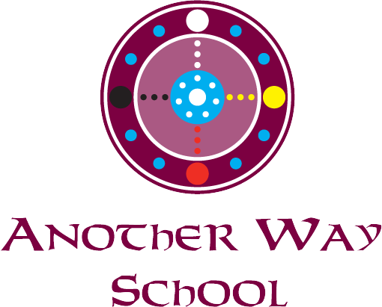
Parent/ Guardian Approval Pick Up List

I, _________________________________________ give my permission for,
____________________________________ to be picked up from school by:

Name __________________________ Phone _____________________

Name __________________________ Phone _____________________

Name __________________________ Phone _____________________

Please make sure that your approved party has a photo ID with them when they come to pick up your child.

Sign _____________________________ Date _______________
Parent/Guardian

Sign______________________________ Date ________________
Parent/Guardian

